Hello all, my name is Julien Andonov.

From 2011 or so, I have been dealing mainly with several problem dealers, but most notably: Oracle, MySQL and PostgreSQL. Recently, I started to deal with new bullies like Mongo and Cassandra. I am happy to learn new things and to share. I really like to teach people and I have done over 30 free courses for: Oracle and MySQL. I managed to achieve one of my dreams by becoming: Oracle Certified Master for 11g Database, which I would like to upgrade to 12c when I have free time. So I am not sure, I will do it in the next 90 years :) For the people interested in my hobbies, I have pretty eccentric ones.

Hiking is an exhilarating passion that captivates my spirit like nothing else. The mere thought of embarking on a journey through winding trails, surrounded by towering trees and vibrant wildflowers, fills me with an insatiable sense of excitement. There's a unique thrill in each step, as I traverse diverse landscapes, from rugged mountain peaks to tranquil meadows. The rhythmic crunch of gravel beneath my boots and the crisp scent of pine in the air serve as constant reminders of the raw beauty of nature that envelops me. With every ascent, I feel a profound connection to the earth beneath my feet and a sense of liberation as I leave the constraints of urban life behind. Whether it's a challenging trek to a remote summit or a leisurely stroll along a scenic trail, hiking rejuvenates my soul and ignites my adventurous spirit like no other pursuit.

— Diving is an unparalleled adventure that beckons me with its allure of the unknown depths. From the moment I slip beneath the surface, enveloped by the cool embrace of the ocean's embrace, a sense of wonder washes over me. The underwater world unfolds in a mesmerizing display of vibrant coral reefs, teeming with an array of marine life that dances in harmony with the currents. With each descent, I am transported to a realm of tranquility, where time seems to stand still and all worries fade away. The rhythmic sound of my breath becomes a comforting companion as I explore intricate underwater landscapes, discovering hidden caves and mysterious shipwrecks. Every encounter with sea creatures, from graceful sea turtles to elusive octopuses, fills me with awe and reverence for the delicate balance of marine ecosystems. Diving is not merely a hobby; it's a profound connection to the vast blue expanse that covers our planet, a source of endless fascination and boundless exploration. Of course, that doesn't come without the necessary certification for Open water diver and Advanced open water diver.

Flying is a passion that courses through my veins, lifting me to heights of exhilaration that defy description. From the moment I step onto the runway and feel the hum of engines beneath me, I am filled with a sense of anticipation that borders on euphoria. As the plane ascends into the boundless sky, the world below shrinks to miniature, and I am overcome with a profound sense of freedom. The sensation of soaring through clouds, with nothing but endless horizons stretching before me, is unmatched by any earthly experience. Whether I'm gazing out at majestic landscapes or marveling at the twinkling lights of cities far below, each moment spent in flight is a testament to the wonder of human ingenuity and the sheer joy of exploration. Flying isn't just a means of transportation; it's a symphony of sights, sounds, and sensations that stirs my soul and reminds me of the limitless possibilities that await beyond the clouds. To enjoy this freedom I obtained Private Pilot License and to enjoy the mystery of the darkness, I added Night Rating to it. In the future I will be happy to dive into the unknown with IFR rating. A part of that I am walking collection of useless facts. Usually linked with history or physics.
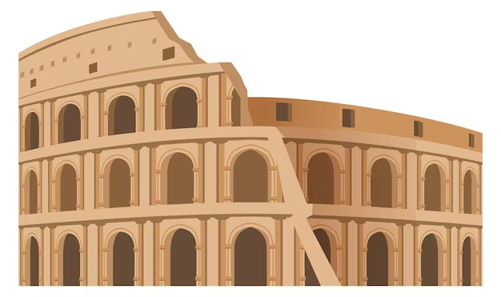
History of the Roman Empire burns brightly, a flame ignited by the captivating narratives of triumph and tragedy that echo through the corridors of time. Delving into the annals of this ancient civilization fills me with a sense of wonder and admiration for the ingenuity, ambition, and resilience of its people. From the rise of Rome as a small city-state to its zenith as a sprawling empire spanning three continents, every chapter reveals tales of conquest, innovation, and cultural exchange that continue to shape the modern world. The legacies of great emperors, visionary architects, and formidable warriors inspire me to delve deeper, to uncover the secrets of their successes and the lessons of their failures. Exploring the intricacies of Roman politics, society, and warfare is not merely an academic pursuit but a journey of discovery that fuels my imagination and enriches my understanding of humanity's collective past.
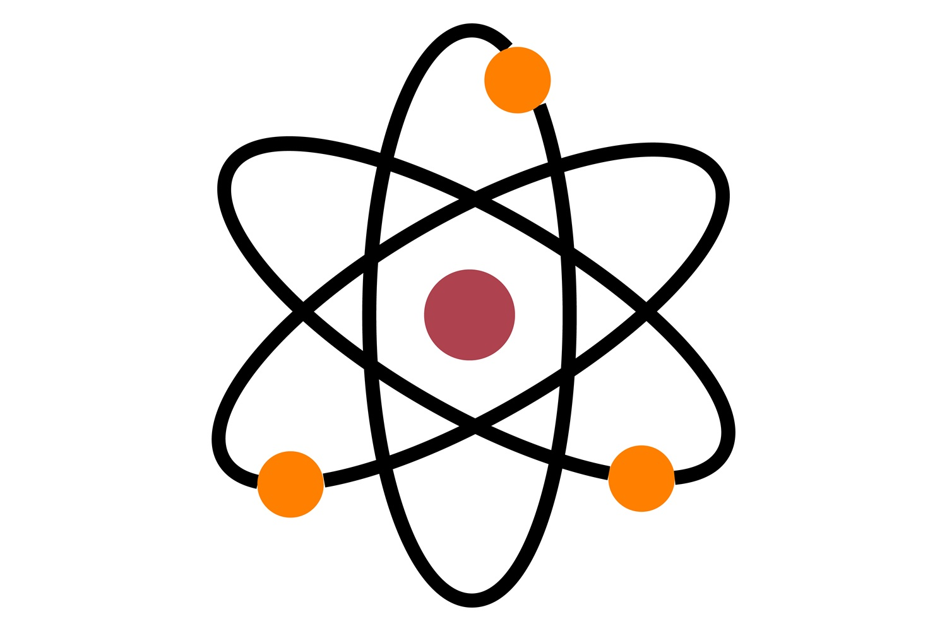
Physics is akin to a symphony of the cosmos, each discovery and theory composing a movement that resonates with the deepest fibers of my being. From the graceful dance of celestial bodies to the intricate interplay of subatomic particles, I am enthralled by the elegance and complexity of the universe. The pursuit of understanding the fundamental laws that govern nature fills me with an insatiable curiosity and a sense of exhilaration. Whether pondering the mysteries of black holes or unraveling the secrets of quantum mechanics, I am drawn to the challenge of unlocking the secrets of the universe. In the realm of physics, I find not only intellectual stimulation but also a profound appreciation for the beauty and order that underlie the chaos of existence. It is a journey of exploration that fuels my imagination and inspires me to delve deeper into the fabric of reality, forever seeking to uncover its deepest truths.

Astronomy, the boundless voyage through the cosmos, where each twinkle in the night sky whispers a tale of cosmic wonder and discovery. From the breathtaking beauty of distant galaxies to the enigmatic dance of celestial bodies, I am captivated by the majesty and mystery of the universe. Peering through the lens of a telescope, I am transported to distant realms millions of light-years away, where the laws of physics govern the fate of stars and the birth of new worlds. The intricate tapestry of constellations and nebulae fills me with a sense of awe and humility, reminding me of the infinitesimal scale of our existence amidst the vastness of space and time. With every new observation and astronomical breakthrough, my fascination only deepens, driving me to explore the furthest reaches of the cosmos and to unlock the secrets of the universe. In the pursuit of understanding our place in the cosmos, I find not only intellectual stimulation but also a profound sense of connection to the cosmic symphony that surrounds us.
Even if one person learns something from this wiki, it will be great success for me. I hope you enjoy it. In case you have any questions I will be happy to help.
Skype: Julien.Andonov Julien.v.andonov@googlemail.com Enjoy!



