Overview
If you want to install Ansible on windows, you will encounter the fact that Ansible doesn't run on windows. At least not natively. There are 2 ways how to operate with ansible on Windows:
- Using Cygwin
- Installing ubuntu Subsystem (only Windows 10+)
We will do it both ways here :)

Cygwin
Downloading and installing Cygwin is fairly easy. Just download the Cygwin and select ansible in the package:
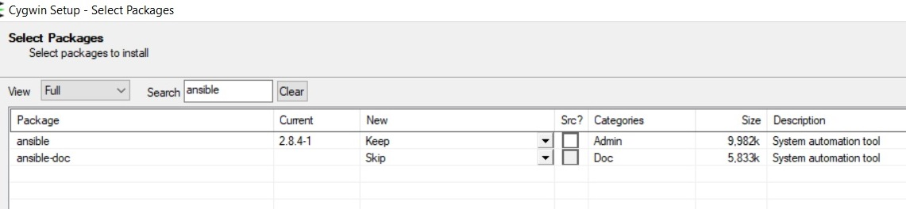
After that you will have the ansible command
Cygwin intro

Ubuntu SubSystem
The ubuntu subsystem is available from the windows store and can be installed on Windows 10+ After you install the ubuntu WS, we have to install couple other stuff before ansible :) So let's get going. Firstly, we have to update our repo:
Update Repo
Then we have to install the pip:
Installing Pip
Really finally, we can install the ansible using the pything indexing or the Pip
Install ansible

