Routing protocols Overview
Now it is the time to configure routing protocol. The purpose of a routing protocol is to learn of available routes that exist on the network, build routing tables and make routing decisions. We will be using OSPF to design the network. There are two types of Routing Protocols – Distance Vector protocols and Link State protocols. In this lab part, we will be using the one of the Link state protocols – Open Shortest Path First routing protocol for communication between the routers. Configuring OSPF routing protocol on routers in GNS3
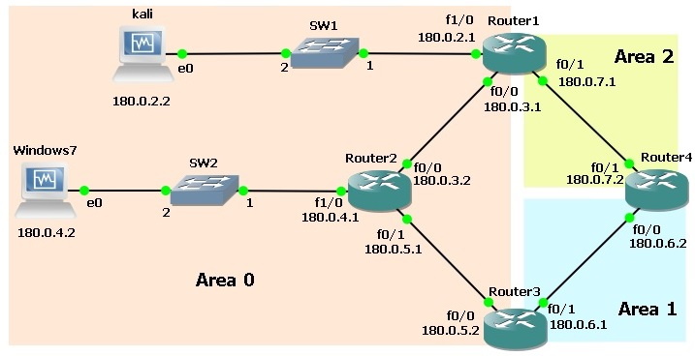

Configuring OSPF routing protocol:
Configure OSPF routing authentication against fake router attack:

Configuring BGP Protocol:
Overview:
The Border Gateway Protocol (BGP) is one of a family of IP Routing protocols, and is an Exterior Gateway Protocol (EGP). BGP (Border Gateway Protocol) is a protocol for exchanging routing information between gateway hosts (each with its own router) in a network of autonomous systems. The current version of BGP is BGP version 4. BGP is often the protocol used between gateway hosts on the Internet. BGP is designed to exchange routing and reachability information between autonomous systems on the Internet.
What it does ?
In a vectoring protocol like BGP, the gateway routers exchange network reachability information with their nearest neighbors. In other words, the routers communicate to each other the sets of addresses (“address prefixes”) that they can reach, and the next hop address to which data should be sent in order to reach those addresses. The routing table contains a list of known routers, the addresses they can reach, and a cost metric associated with the path to each router so that the best available route is chosen. Hosts using BGP communicate using the Transmission Control Protocol (TCP) and send updated router table information only when one host has detected a change. Only the affected part of the routing table is sent. BGP communicates with autonomous (local) networks using Internal BGP (IBGP). In this lab you will be designing your network that includes both IBGP and EBGP.
How it works ?
In the world of BGP, each routing domain is known as an autonomous system, or AS. What BGP does is help choose a path through the Internet, usually by selecting a route that traverses the least number of autonomous systems: the shortest AS path. BGP only knows about these paths based on updates it receives. Unlike Routing Information Protocol (RIP), a distance-vector routing protocol which employs the hop count as a routing metric, BGP does not broadcast its entire routing table. At boot, BGP neighbor, called peer will hand over its entire table. After that, everything relies on updates received. Peers are established by manual configuration between routers to create a TCP session on port 179. A BGP speaker sends 19-byte keep-alive messages every 60 seconds to maintain the connection. Among routing protocols, BGP is unique in using TCP as its transport protocol. Route updates are stored in a Routing Information Base (RIB). A routing table will only store one route per destination, but the RIB usually contains multiple paths to a destination. It is up to the router to decide which routes will make it into the routing table, and therefore which paths will actually be used. In many cases, there will be multiple routes to the same destination. BGP therefore uses path attributes to decide how to route traffic to
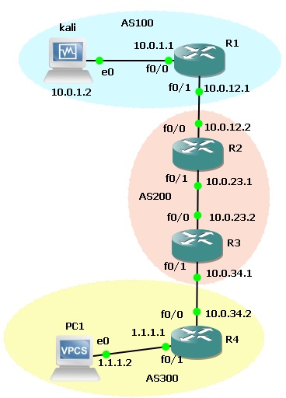
Configuring the routers and neighbors, after the IP configuration has been down (references up)

