Overview
Like any other Database, mongo is also obliged to provide Active/Active load balancing configuration. Also like many other databases (except Oracle) Mongo doesn't require shared storage or ultra-complex configuration / prerequisites in order to provide this. In fact, so far, Mongo was the easiest Active / Active and Active / Passive Configuration which I ever configured.

Set up Mongo Instances
The set up of the Mongo Instances was already provided in the previous sections, just install the following packages on each server and disabled the selinux, and you should be good to go:
In our configuration we will have 4 servers in order to configure Mongo sharding:
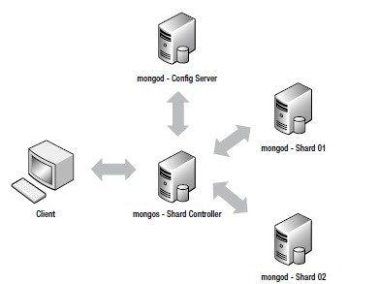
- lparamongo - Mongos - Config Server - Used to store information about the sharded configurations
- lparbmongo - Mongod - Shard Controller - Used as a proxy for the clients to connect
- lparcmongo - Mongod-Shard1 - Used to store part of the shredded data
- lpardmongo - Mongod-Shard2 - Used to store the other part of the shredded data.
So let's get started :)

Config Server Database
As everything with Mongo, things are simple, just run your database with the –configsvr option:
Next we have to configure the shard controller to connect to this database as follows:
With this, the shard controller is connected to our config database.

Start up the Shard servers
The shard servers has to be started as normal:

lparcmongo

lpardmongo
Once the servers are started we have to configure the shards to communicate via the proxy shard controller. In order to do that, just connect to the shard controller and add them in the configuration:
So far we have added sharding but didn't enable it, nor we have created some sharded collection. In order to enable sharding we have to enable it and we have to specify a shard key for a collection as follows:
Unlike other databases, where the software specify how a data should be distributed in Mongo, the DBA has a total control of how the data is to be spread among the nodes.

