Overview
Installation of Nagios XI can be done in two ways.
- Automatic
- Manual
Both ways are pretty easy and very similar. In both cases, the procedure will verify the database, the necessary packages and other requirements. Let's start with the automatic way :)

Automatic
In order to automatically install, we can simply run the following command:
Nagios Install
After lengthy installation, we have to change the permissions of the installation.
We can connect to the server using a browser on the following address
http://IP_adress/nagiosxi
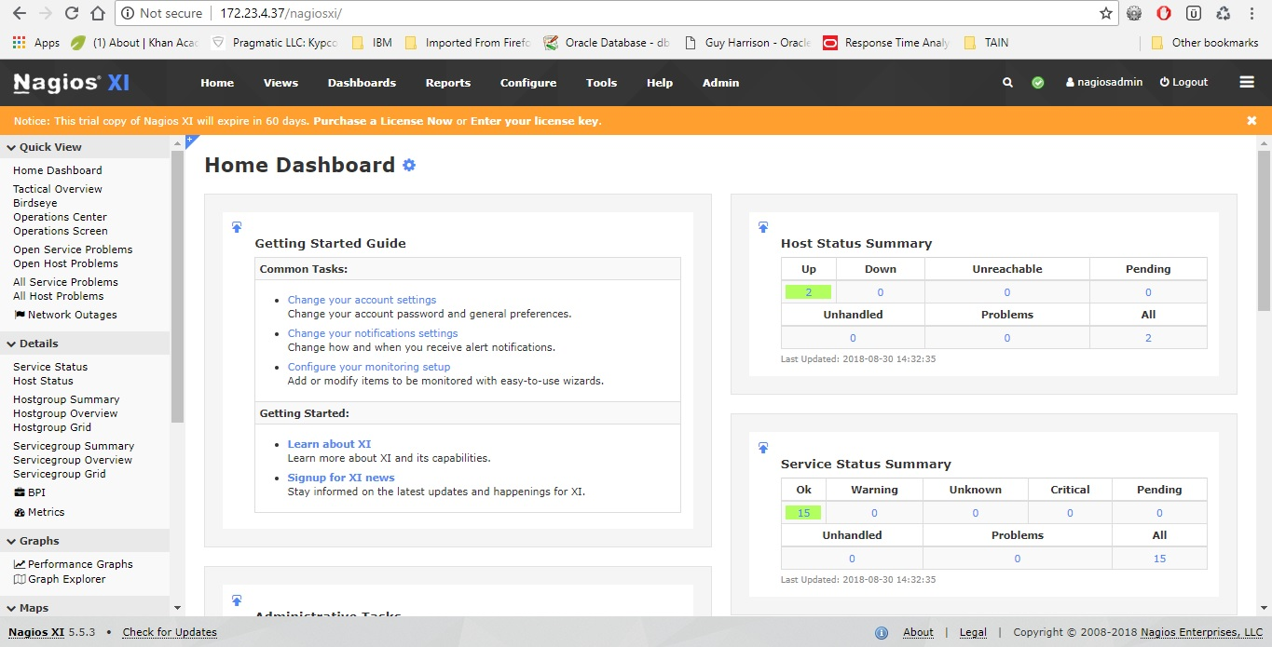

- Create new services from:
Configure → Configuration Wizards
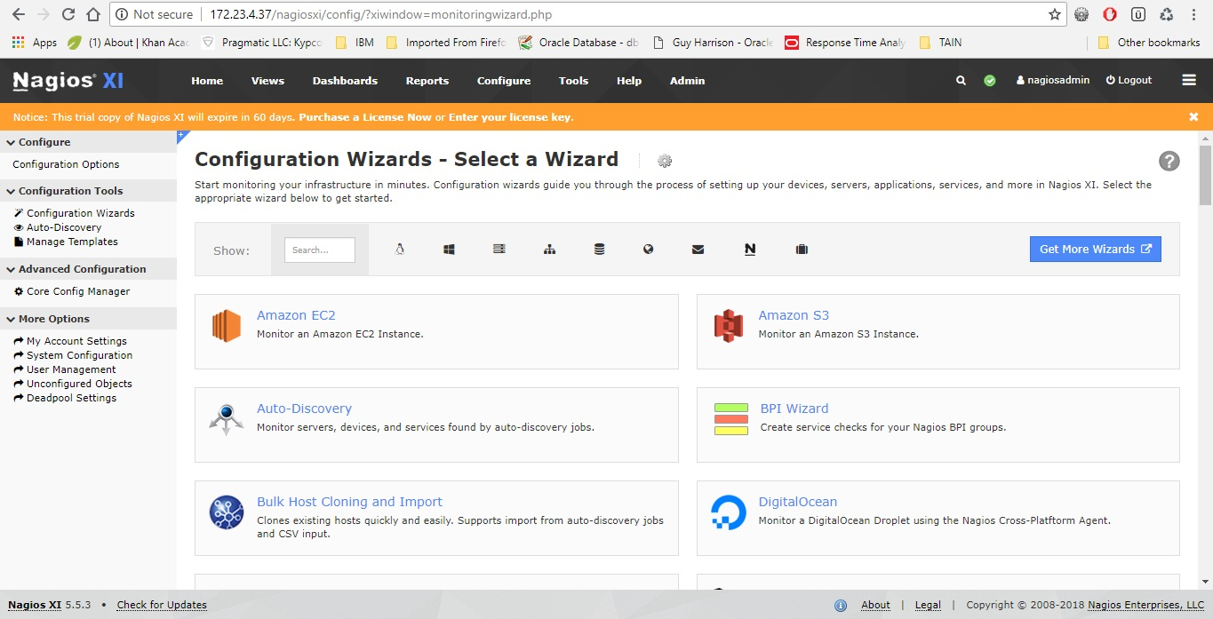

- Review & Modify existing services from:
Configure → Core Config Manager
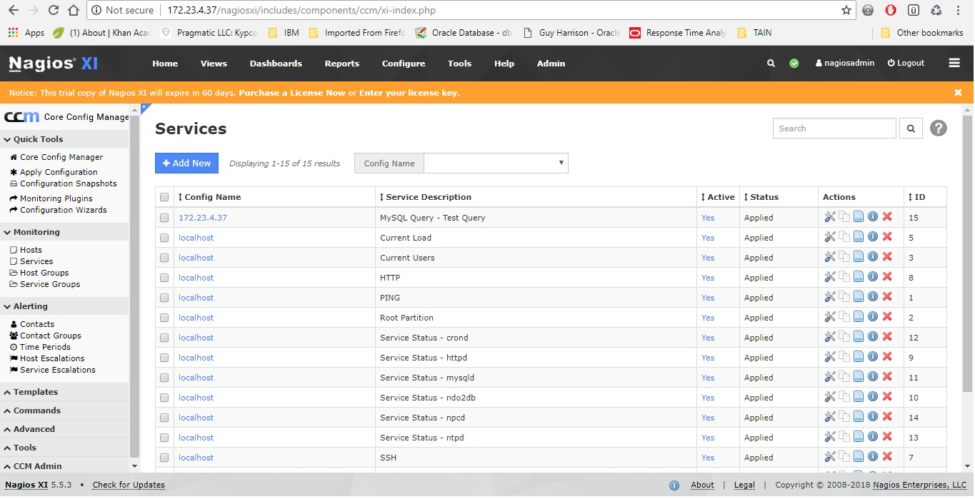

- Monitor existing services
Home → BBmap → Services:
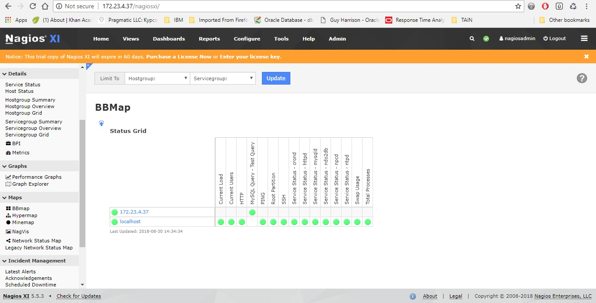
You will have to of course configure the new service (username,password) if it will be regarding database or a server. Which includes creation of a monitoring user with the correct privileges and accesses. Furthermore, once the Nagios XI is installed, you will have to reset the root password for the mysql/mariaDB database.

