Overview
OCI or Oracle Cloud Infrastructure is a cloud provisioning by Oracle which offers: PaaS, IaaS and others services. Firstly, to get access to OCI, we need Oracle account for OCI, which you can create for free at: “cloud.oracle.com” Like any other cloud infrastructure, there are whole books you can read of the architecture and the processes, but in a nutshell, you can think of it, as something like this:
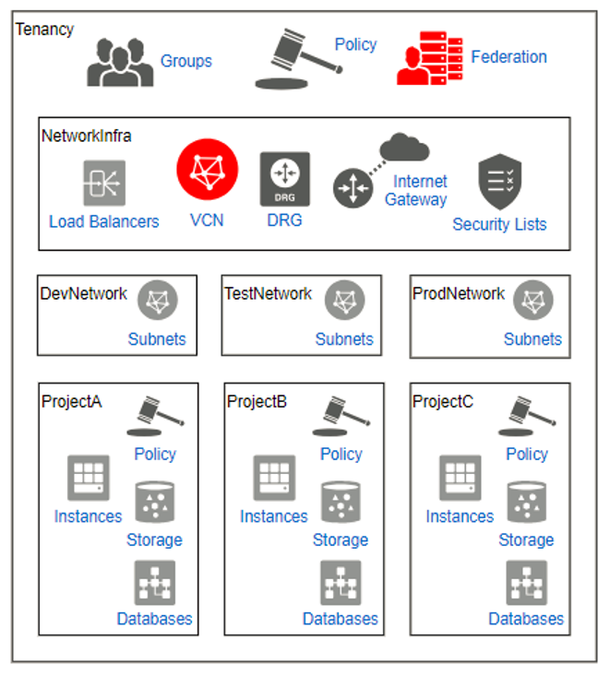

Configuration
Once you have your account, your tenancy and your root compartment. It is important to set your configuration. The “config” file should be in your home location under the .ssh/ folder. Otherwise, you won't be able to connect. The configuration should have something like that.
Config file
Of course, use yours user and tenancy OCIDs, as well as the private key of the public key you have added as API key.

