Overview
Oracle Golden gate for Big data is a separate software than the standard Oracle Golden Gate, so you need to download it from the edelivery or the oracle site.
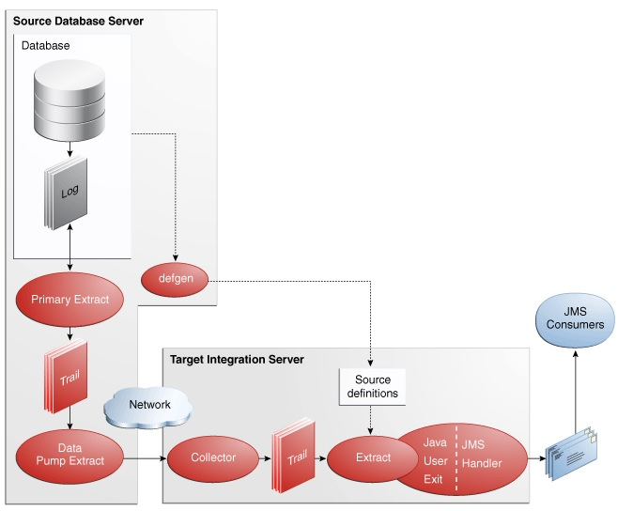

Installation
Unzip

Configure Source
The source is standard Oracle Golen Gate 12c and it just extract from a schema: oggsrc and send data to the replicat in a normal / standard way:
Configuration

Configure Destination
The destination will accept the data from the source (standard Oracle Golden Gate) and send it to ActiveMQ via Java Handler

Configure Manager
Configure Oracle Golden Gate for Big Data

Configure Replicat
Add Replicat
Create the Java Adapter Properties file: jmsrep.properties
Edit jmsrep.properties

