Overview
In this section we will replicate from Oracle → Golden Gate → HDFS
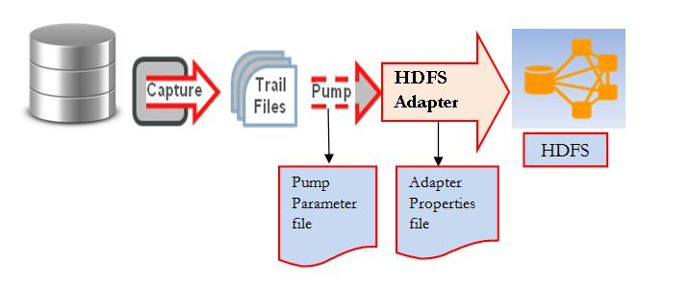

Configuration Destination
Create HDFS Properties File (TRG_GGHOME/dirprm/hdfs.properties)

Create Replicat
Create Replication

Test
To test, we can connect to the Source database and issue insert:
Insert Data
Check the replication:
Check source and dest statistics

