Overview
Updates in Oracle Enterprise Manager Cloud control can be done in two ways:
- Online - Requires Access to the Oracle support
- Offline - Download the software and upload it to the OMS and the target host

Offline
Since oracle goes backwards to common sense. In 12c+ we have to upload the latest catalog (that is latest versions of agents, plugins and so on) to the OMS.
It is important to mention that the catalog doesn't contain the software itself, but rather only list of them with the location of the location to download them.
So let's update the catalog:

Catalog Update
I spent A LOT OF TIME to find the location to download the files, but in nutshell you have to download the latest update from: https://updates.oracle.com/Orion/Download/download_patch/p9348486_112000_Generic.zip
That link can be found in:
https://docs.oracle.com/cd/E73210_01/EMADM/GUID-ECA444F6-88B3-436D-8B96-F65581AD2E2E.htm#GUID-5DF33C50-59DD-4187-B769-D66E886EC1BB
After you upload the file to the OMS Host you can upload it to the OMS itself:
After the catalog has been updated we can download the software itself. In our case, we will manually upload the agent. The upload of the agent is used to distribute that agent centrally to other hosts.
In our case we will upload teh SQL Server Agent.

Agent Update
Since we are doing it, let's do also plugin:

Plugin Update
Once we update the catalog, navigate to oms:
- Settings → Extensability → Self Update
- Self Update → Plugins → SQL Server → Download
Once you press the Download, the OMS will show you the following message:
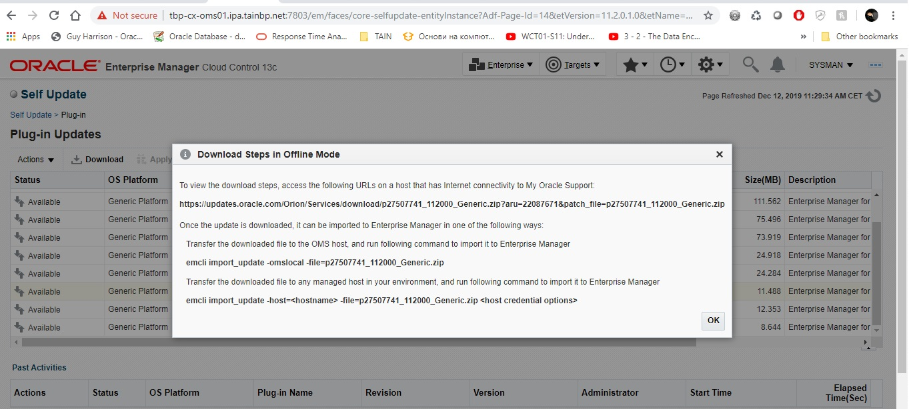
After you download the file and upload it on the OMS server, we have to upload it to OMS as instructed:

