Overview
Migration from single instance to RAC database, can be done in two ways depending if downtime is possible:
- Creating Physical Standby database
- Restore template with DBCA on another server
- Using the RConfig
In our case we will use the RConfig tool. So let's get going
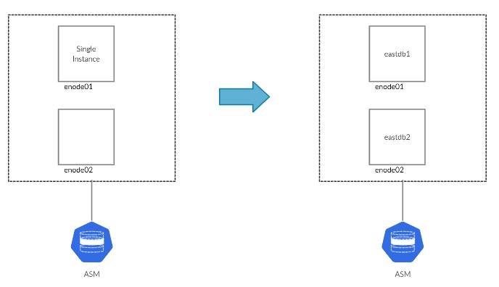

Prepare the environemnt
Firstly we can check how the database is configured:
Check database configuration
Be sure to take an offline backup of the single instance database, preferably with RMAN:
Create offlien backup
In case the database has a standby increase archivelog apply gap:
Increase archivelog gap

Test the conversion
With that, we can test if the conversion will succeed as follows:
Test
After we are sure that the operation will succed we can modify the parameter as follows:
Modiy the parameter

Migration
Finally, run the migration as follows:
Migrate
Once that is done, we can test the database configuration:
Check the reconfiguration

